**DAILY ONLINE ACTIVITIES SUMMARY**

|  |  |  |  |  |  |  |  |  |
| --- | --- | --- | --- | --- | --- | --- | --- | --- |
| **Date:** | **18-05-2020** | | | | | **Name:** | **Chetana H** | |
| **Sem & Sec** | **VI A** | | | | | **USN:** | **4AL17CS021** | |
| **Online Test Summary** | | | | | | | | |
| **Subject** | | **CNSC IA Test** | | | | | | |
| **Max. Marks** | | **60** | | **Score** | | | **35** | |
| **Certification Course Summary** | | | | | | | | |
| **Course** | **Python for Machine learning** | | | | | | | |
| **Certificate Provider** | | | **GreatLearning** | | **Duration** | | | **5hr** |
| **Coding Challenges** | | | | | | | | |
| **Problem Statement:**  **1.**Using methods charAt() & length() of String class, write a program to print thefrequency ofeach character in a string.  **2.**Write down a java program to print even and odd numbers series respectivelyfrom twothreads: t1 and t2 synchronizing on a shared object Let t1 print message “ping — >” and t2 print message “,—-pong”. . | | | | | | | | |
| **Status:Completed,executed** | | | | | | | | |
| **Uploaded the report in Github** | | | | | **Yes** | | | |
| **If yes Repository name** | | | | | <https://github.com/chetana-H/certification-and-online-coding> | | | |
| **Uploaded the report in slack** | | | | | **Yes** | | | |

**Online Certification Details**

Modules completed:

-Why python, python vs R,

-Anaconda installation,Intro to Jupyter Notebook-2

-Jupiter Notebook Shortcut-2

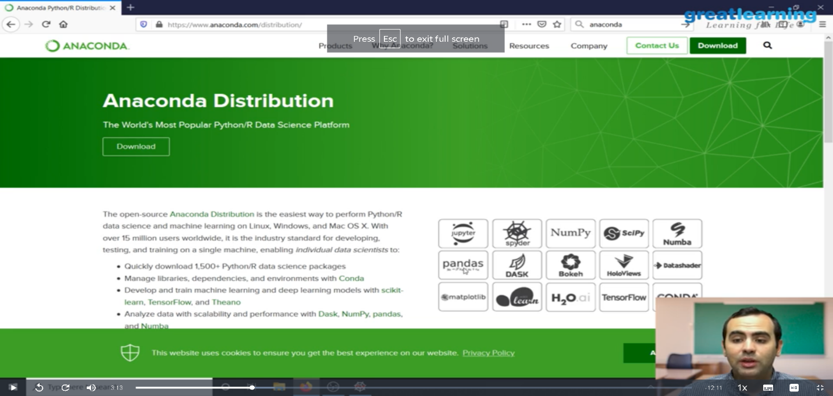

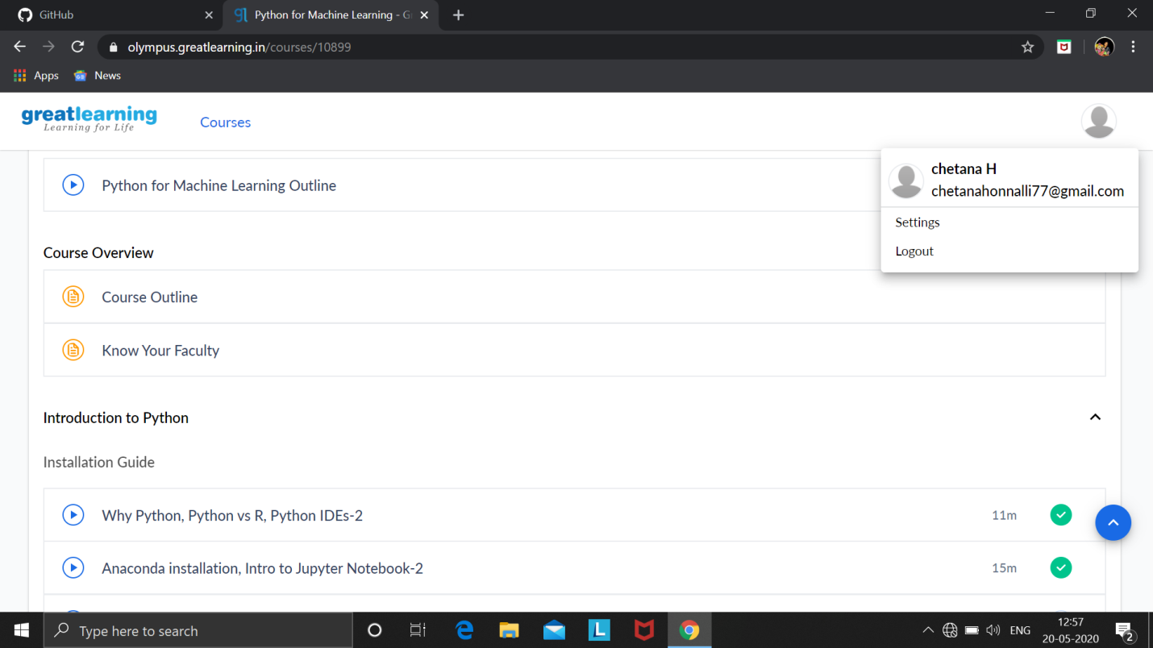

**Coding Challenge Details**

1. Using methods charAt() & length() of String class, write a program to print the frequency of each character in a string.

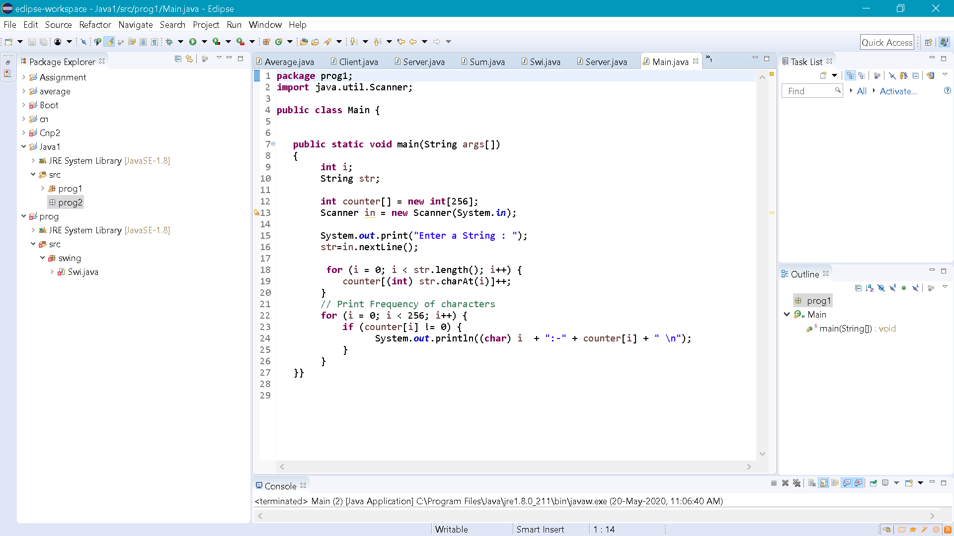

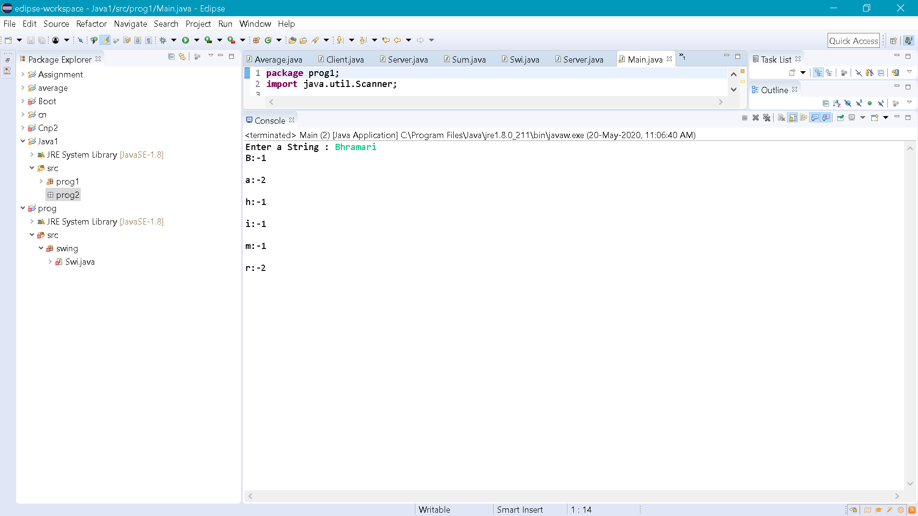

1. Write down a java program to print even and odd numbers series respectively from two threads: t1 and t2 synchronizing on a shared object  
   Let t1 print message “ping — >” and t2 print message “,—-pong”.

